

Welcome Back
We would like to welcome everyone back for Term 3 at Deanpark Nursery School. We hope you enjoyed the festive break and we look forward to continuing to work together for this next term.

Toy fund
This is a voluntary donation of £2 per child. If you are having problems paying toy fund, then please speak to a member of management.
This money helps to buy resources for the children as well as pays towards birthday presents, trips, parties and other essential items needed for the children.
A member of staff will be in the play room on a Tuesday and Thursday to collect toy-fund. Toy fund can also be handed in at any time during the week. You only have to pay toy fund on one of those days, not both.
Between August 2024- December 2024, we collected £602 from Toy Fund. We also raised £199.31 during the Carol Singing. We have spent £688.21 on the Halloween Party, toys from Santa and the Christmas party.

Important information
Can we please ask that parent/carers are mindful of their time when dropping off and collecting their child/ren. Increasingly we are finding parent/carers are dropping their child/ren off too early or are late at collection time; this impacts the staff: child ratio and could cause a safeguarding concern.
We understand that there are occasions where delays in collecting children are unavoidable and staff within the nursery will always be flexible regarding this. However, repeatedly collecting your child late may result in the nursery having to reduce your hours.

Self-Evaluation
A big THANK YOU to all who have responded to our Self-Evaluation questions in 2024. We use your responses to improve our service. We always welcome your comments and suggestions. Your “what three words” describing how you feel about Deanpark have given staff a real boost as they pass the Self-Evaluation noticeboard (on the left as you come into the playroom). You help our nursery grow! We look forward to working together with you in 2025.

Consultation
Our vision, values and aims are based on the unique needs of our children and families in our setting. Developing a vision that is co-created by us with children and families means that everyone is working together for the best interests of the children. It is important to refresh the vision from time to time to ensure that it remains relevant to the community. We will be shortly issuing a consultation to get parent/carer, children’s and staff’s views on the nursery’s current vision and values and making any necessary changes.

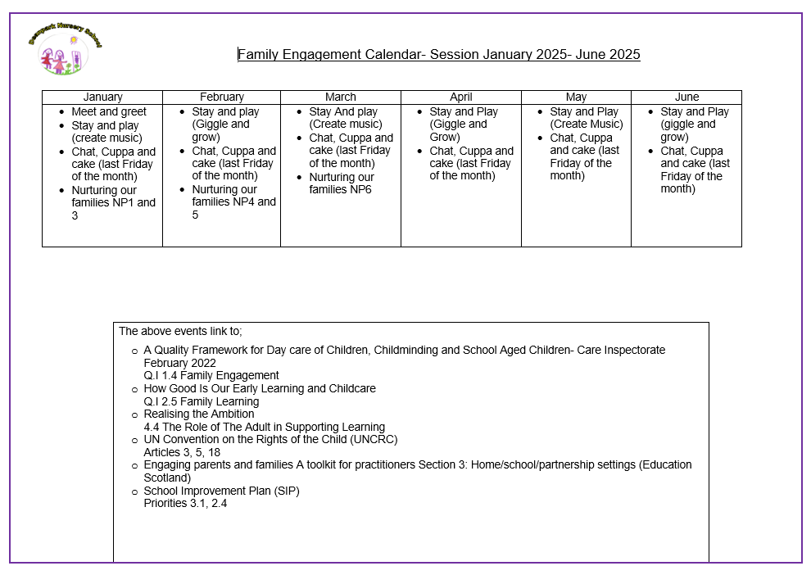

A polite reminder
Can parents/carers please make sure that your child is dressed appropriately for the weather; children access the outdoor area in all weathers. We will provide waterproofs for children were possible, but they may still need jackets, hats, scarves and gloves.
Also, any child who wears nappies/pull-ups, if parents could make sure their bag is stocked with essentials, please. Could you also ensure that you put your child’s name on their clothes, jackets and wellies.
A change of clothes, socks and indoor shoes is also required. Although children wear aprons for messy play and puddle suits outdoors, sometimes the children still need changed after having so much fun with their friends and staff.
If you do not provide spare clothes for your child and your child requires changing, you may be called and asked to return to nursery with a change of clothes.

Celebrations and Festivals
As I explore stories, images, music and poems, I am becoming familiar with the beliefs of the world religions I am learning about. RME 0-04a
Listed below are some of the celebrations we will exploring with the children.
Burns Night 25th January
Chinese New Year 29th January- Year of the Wood Snake
Shrove Tuesday 4th March
Valentine’s Day 14th February
Holi (Hindu) 14th March
Easter Sunday 20th April
Article 30 (children from minority or indigenous groups) Every child has the right to learn and use the language, customs and religion of their family, whether or not these are shared by the majority of the people in the country where they live.

We promote an Open-Door Policy, so please come and speak to a member of the SLT if you have any questions or concerns. Sam

