

Welcome
Welcome back to all our returning children and a very warm welcome to all our new children and families. A very big thank you for choosing Deanpark. We hope they are feeling as excited as we are.

New Children
All children take time to settle into a new environment and every child is an individual.
Please take advice from your child’s key worker regarding settling your child.

We understand this may take some time. However, we aim to make the transition into nursery a happy, smooth and stress-free time!

Staff changes

We would like to welcome back Gill who is returning after a seconded opportunity; Gill will be working with the PINK group on her return.

We would also like to welcome Sadaf. Sadaf has been with us for a few months; getting to know the staff and children. Sadaf and Anna are job share partners and will be working with the BLUE group. Anna will work at the start of the week, and Sadaf will be with the children at the end of the week.

As many of our returning families will be aware, Davie our janitor retired last term. We are pleased to welcome Lesley to the team.

Lastly, Christine joined the team in April as an acting Team Leader. Christine has fitted well into the team and is looking forward to getting to know everyone better in this new term.

Important information
Can we please ask that parent/carers are mindful of their time when dropping off and collecting their child/ren? Increasingly we are finding parent/carers are dropping their child/ren off too early or are late at collection time; this impacts the staff: child ratio and could cause a safe guarding concern.
We understand that there are occasions where delays in collecting children are unavoidable and staff within the nursery will always be flexible regarding this. However, repeatedly collecting your child late may result in the nursery having to reduce your hours.
Toy fund
This is a voluntary donation of £2 per child. If you are having problems paying toy fund, then please speak to a member of management.
This money helps to buy resources for the children as well as pays towards birthday presents, trips, parties and other essential items needed for the children.
A member of staff will be in the play room on a Tuesday and Thursday to collect toy-fund. Toy fund can also be handed in at any time during the week. You only have to pay toy fund on one of those days, not both.

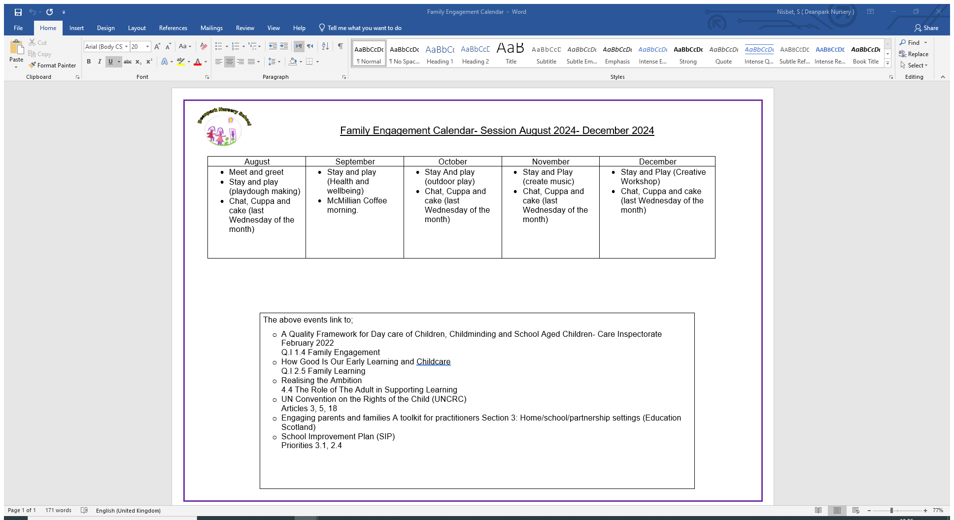
Please remember we have an open-door policy and welcome all parents/carers to speak to a member of management if they need support, want to make a suggestion or celebrate in any successes Sam
Family Engagement
Please see below the calendar of events for the upcoming Family Engagement Programme we are starting.
All parents/carers are welcome and more information will be released closer to the time of the events

Continuous Improvement
We are seeking feedback on our safeguarding policy and procedures. Every month we will be asking parents/carers if they could take a few minutes to help us make improvements to our service by answering a few short questions.
Thank you for your cooperation
Please find attached the QR required for the questions


Celebrations and Festivals
As I explore stories, images, music and poems, I am becoming familiar with the beliefs of the world religions I am learning about. RME 0-04a
Listed below are some of the celebrations we will be exploring with the children.
National Read a Book Day- 6th September
MacMillan Coffee Morning- 26th September
Article 30 (children from minority or indigenous groups) Every child has the right to learn and use the language, customs and religion of their family, whether or not these are shared by the majority of the people in the country where they live.

